
Volunteer Opportunity!

MSUM Blood Drive
November 10, 2026

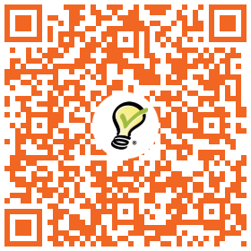
Scan the QR code to volunteer at the check-in desk

